Q1

//Program To Perform All Arithmetic Operations

#include<stdio.h>

int main(){

int a,b,add,subt,mul,div,rem;

printf("Enter First Number: ");

scanf("%d",&a);

printf("Enter Second Number: ");

scanf("%d",&b);

add=a+b;

subt=a-b;

mul=a*b;

div=a/b;

rem=a%b;

printf("\nAddition of %d & %d = %d",a,b,add);

printf("\nSubtraction of %d & %d = %d",a,b,subt);

printf("\nMultiplication of %d & %d = %d",a,b,mul);

printf("\nDivision of %d & %d = %d",a,b,div);

printf("\nRemainder of divison between %d & %d = %d",a,b,rem);

return 0;

}

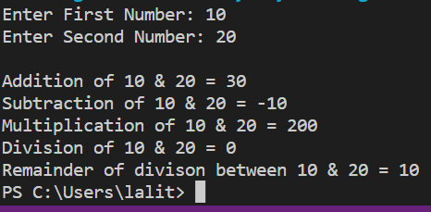

Q2

//Program To Find Area Of A Triangle When Height And Base Are Given

#include<stdio.h>

int main(){

float a,b,area;

printf("Enter Height Of Triangle: ");

scanf("%f",&a);

printf("Enter Base Of Triangle: ");

scanf("%f",&b);

area=0.5*a*b;

printf("The Area of triangle is: %funit^2",area);

return 0;

}

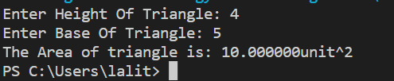

Q3

//Program To Find Third Angle Of A Triangle

#include<stdio.h>

int main(){

int a,b,c;

printf("Enter First Angle: ");

scanf("%d",&a);

printf("Enter Second Angle: ");

scanf("%d",&b);

c=180-a-b; //Sum Of all angle of triangle is 180.

printf("The third angle is: %d",c);

return 0;

}

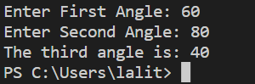

Q4

//Program To Convert Days Into Year Weeks & Days

#include<stdio.h>

int main(){

int a,years,weeks,days;

printf("Enter the total days: ");

scanf("%d",&a);

years=a/365;

weeks=(a%365)/7;

days=a-((years*365)+(weeks*7));

printf("%d = %d years, %d weeks, %d days\n",a,years,weeks,days);

}

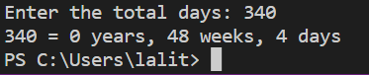

Q5

//Program To Find Power & Square Root Of Any No.

#include<stdio.h>

#include<math.h>

int main(){

int a,expo,c,i,d;

printf("Enter a no.: ");

scanf("%d",&a);

d=sqrt(a);

printf("The square root of given no. is: %d",d);

printf("\nEnter a exponential power for finding power of given num: ");

scanf("%d",&expo);

for(i=0;i<expo;i++){

c=a*a;

}

printf("The power of given no. is: %d",c);

return 0;

}

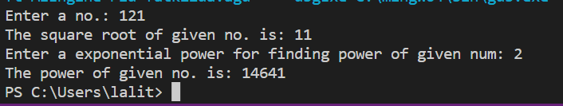

Q6

//Program To Find Total, Average, Percentage & Grade Of Five Subjects Marks

#include<stdio.h>

int main(){

int a,b,c,d,e,total,avg,p;

printf("Enter marks of first subject: ");

scanf("%d",&a);

printf("Enter marks of second subject: ");

scanf("%d",&b);

printf("Enter marks of third subject: ");

scanf("%d",&c);

printf("Enter marks of fourth subject: ");

scanf("%d",&d);

printf("Enter marks of fifth subject: ");

scanf("%d",&e);

total=a+b+c+d+e;

avg=total/2;

p=total/5;

printf("Total=%d\nAverage=%d\nPercentage=%d%c",total,avg,p,37);

if(p<=100 && p>=90){

printf("Grade=A!!");

}

else if(p<=89 && p>=80){

printf("Grade=B!!");

}

else if(p<=79 && p>=60){

printf("Grade=C!!");

}

else if(p<=59 && p>=40){

printf("Grade= D!!");

}

else if(p<=39 && p>=27){

printf("Grade=E!!");

}

else

printf("Better Luck Next Time!!");

return 0;

}

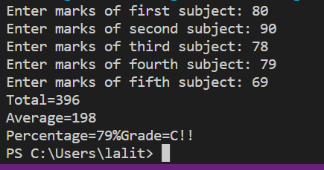

Q7A

//Program To Check LSB

#include<stdio.h>

int main(){

int num;

printf("Enter the number: ");

scanf("%d",&num);

if(num & 1)

printf("LSB of %d is se(1).",num);

else

printf("LSB of %d is unset(0).",num);

return 0;

}

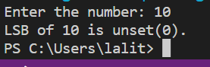

Q7B

//Program To Check MSB

#include<stdio.h>

#define BITS sizeof(int)*8

int main(){

int num,msb;

printf("Enter the number: ");

scanf("%d",&num);

msb=1<<(BITS-1);

if(num & 1)

printf("MSB of %d is se(1).",num);

else

printf("MSB of %d is unset(0).",num);

return 0;

}

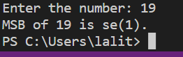

Q8A

//Program To Check MSB

#include<stdio.h>

#define BITS sizeof(int)*8

int main(){

int num,msb;

printf("Enter the number: ");

scanf("%d",&num);

msb=1<<(BITS-1);

if(num & 1)

printf("MSB of %d is se(1).",num);

else

printf("MSB of %d is unset(0).",num);

return 0;

}

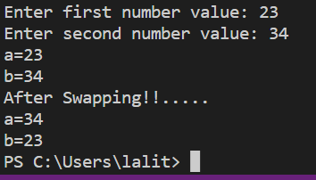

Q8B

//Program To Swao To No. By Using Third Variable

#include<stdio.h>

int main(){

int a,b,temp;

printf("Enter first number value: ");

scanf("%d",&a);

printf("Enter second number value: ");

scanf("%d",&b);

printf("a=%d\nb=%d",a,b);

temp=a;

a=b;

b=temp;

printf("\nAfter Swapping!!.....");

printf("\na=%d\nb=%d",a,b);

return 0;

}

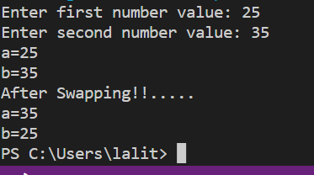

Q9

//Program To Find Max No. Using ternary Operator

#include<stdio.h>

int main(){

int a,b,c,max;

printf("Enter first number: ");

scanf("%d",&a);

printf("Enter second number: ");

scanf("%d",&b);

printf("Enter third number: ");

scanf("%d",&c);

max=(a>b && a>c)?(a):((b>c)?(b):(c));

printf("Max No. is: %d",max);

return 0;

}

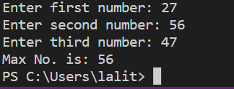

Q10

//Program To Count Alphabet, Digits & Special Character Using Conditional Operator

#include<stdio.h>

int main(){

char str[20];

int i,c1=0,c2=0,c3=0,c4=0;

printf("Enter string: ");

gets(str);

for(i=0;str[i]!='\0';i++){

if(str[i]>='A' && str[i]<='Z')

c1++;

else if(str[i]>='a' && str[i]<='z')

c2++;

else if(str[i]>='0' && str[i]<='9')

c3++;

else

c4++;

}

printf("Capital alphabets=%d\nSmall alphabets=%d\nDigits=%d\nSpecial character=%d",c1,c2,c3,c4);

return 0;

}

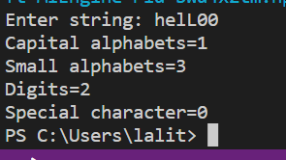

Q11

//Calculate Electricity Bill

#include<stdio.h>

int main(){

int unit;

float total;

printf("Enter your electricity unit consumption: ");

scanf("%d",&unit);

if(unit <= 50)

total=unit*0.5;

else if(unit<=150)

total=(50*0.5)+((unit-50)*0.75);

else if(unit<=250)

total=(50*0.5)+(100*0.75)+(100*1.2)+((unit-250)*1.5);

printf("Your total bill is: Rs.%f",total);

return 0;

}

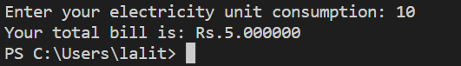

Q12A

//Program To Create Simple Calculator Using Switch Case

#include<stdio.h>

int main(){

float a,b,c;

char ch;

printf("Enter first no.: ");

scanf("%f",&a);

printf("Enter second no.: ");

scanf("%f",&b);

printf("Enter user choice to perform operations: ");

scanf("%s",&ch);

switch(ch){

case '+':c=a+b;

printf("Sum of %f & %f is: %0.2f",a,b,c);

break ;

case '-':c=a-b;

printf("Difference of %f & %f is: %0.2f",a,b,c);

break ;

case '*':c=a*b;

printf("Multiplications of %f & %f is: %0.2f",a,b,c);

break ;

case '/':c=a/b;

printf("Division of %f & %f is: %0.2f",a,b,c);

break ;

default :printf("Invalid operations!!");

break;

}

}

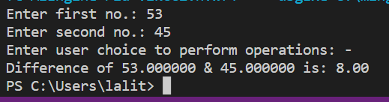

Q12B

//Program To Create Days Of Week Using Switch Case

#include<stdio.h>

int main(){

int a;

printf("Enter a day no.: ");

scanf("%d",&a);

switch(a){

case 1:printf("Sunday!!");

break ;

case 2:printf("Monday!!");

break ;

case 3:printf("Tuesday!!");

break ;

case 4:printf("Wednesday!!");

break ;

case 5:printf("Thursday!!");

break;

case 6:printf("Friday!!");

break;

case 7:printf("Saturday!!");

break;

default :printf("Invalid Day!!");

break ;

return 0;

}

}

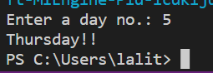

Q13

//Program To Check Vowel Or Consonamts Using Switch Case

#include<stdio.h>

int main(){

char ch;;

printf("Enter a alphabet: ");

scanf("%c",&ch);

if((ch>='A' && ch<='Z')||(ch>='a' && ch<='z')){

switch(ch){

case 'A':

case 'E':

case 'I':

case 'O':

case 'U':

case 'a':

case 'e':

case 'i':

case 'o':

case 'u':

printf("%c is a Vowel!!....",ch);

break ;

default:

printf("%c is a Consonant!!....",ch);

}

}

else

printf("\n %c is not an alphabet!! ",ch);

return 0;

}

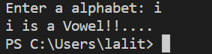

Q14

//COUNT +V , -V, Zero

#include<stdio.h>

int main(){

int n,i,count=0,flag=0,red=0;

printf("Enter the size of an array: "); //Taking Size Of An Array

scanf("%d",&n);

int a[n];

for(i=0;i<n;i++){ //Taking Value Of Elements

printf("Enter the value for index%d: ",i);

scanf("%d",&a[i]);

}

for(i=0;i<n;i++){

if(a[i]>0){

count++;

}

else if(a[i]<0){

flag++;

}

else {

red++;

}

}

printf("Total no. of +v no. is:%d\nTotal no. of -v no. is:%d\nTotal no. of 0 no. is:%d",count,flag,red);

}

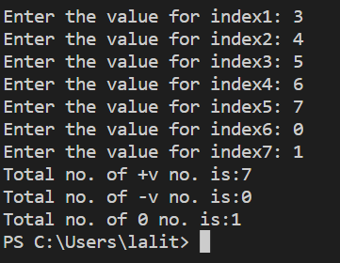

Q15

//Program To Check A Triangle Is Equilateral, Isosceles Or Scalene Triangle

#include<stdio.h>

int main(){

int a,b,c;

printf("Enter first side of triangle: ");

scanf("%d",&a);

printf("Enter second side of triangle: ");

scanf("%d",&b);

printf("Enter third side of triangle: ");

scanf("%d",&c);

if(a==b && b==c){

printf("\nTriangle is Equilateral");

}

else if(a==b||b==c||c==a){

printf("\nTriangle is Isosceles");

}

else{

printf("\nTriangle is Scalene");

}

return 0;

}

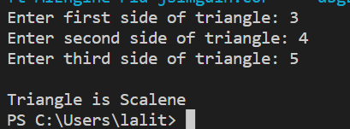

Q16

//PROGRAM TO PRINT NATURAL NO. AND FIND ITS SUM

#include <stdio.h>

int main(){

int n,i,c=0;

printf("Enter the limit: ");

scanf("%d",&n);

for(i=1;i<=n;i++){

printf("%d\n",i);

c=c+i;

}

printf("\nThe sum no. till end is: %d",c);

return 0;

}

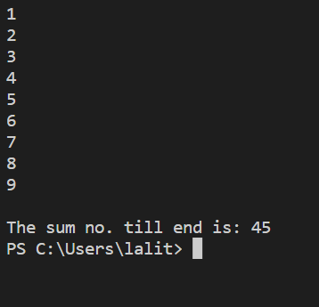

Q17

//CHECKING NO. IS EVEN OR ODD

#include <stdio.h>

int main(){

int n,c=0,i;

printf("Enter the limit: ");

scanf("%d",&n);

for(i=1;i<n;i++){

if(i%2==0){

printf("\n%d",i);

c=c+i;

}

}

printf("\nThe sum of even no. till end is: %d",c);

return 0;

}

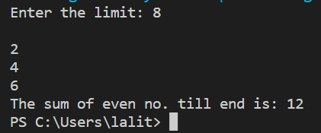

Q18

//TABLE USING FOR LOOP

#include <stdio.h>

int main(){

int n,i;

printf("Enter a num to find its table: ");

scanf("%d",&n);

for(i=1;i<=n;i++){

printf("%d*%d=%d\n",n,i,n*i);

}

}

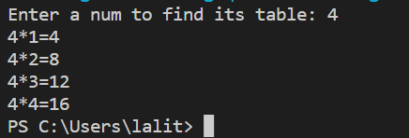

Q19

//FACTORIAL FINDING

#include <stdio.h>

int main(){

int n,fact=1;

printf("Enter a no to find its factorial: ");

scanf("%d",&n);

while(n>0){

fact=fact*n;

n=n-1;

}

printf("%d",fact);

}

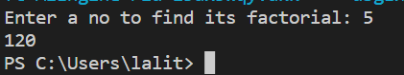

Q20

//PALINDROME NO.

#include<stdio.h>

int main(){

int n,temp,rem,sum=0;

printf("Enter a no. to chech whether PALINDROME or not: ");

scanf("%d",&n);

temp=n;

while(n>0){

rem=n%10;

sum=(sum*10)+rem;

n=n/10;

}

n=temp;

if(n==sum)

printf("PALINDROME NO.");

else

printf("NOT A PALINFROME NO.");

}

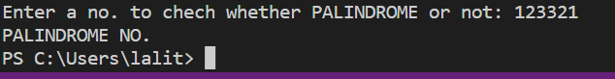

Q21

//COUNT FREQUENCY OF A GIVEN ARRAY

#include<stdio.h>

int main(){

int n,i,key,count=0;

printf("Enter the size of an array: "); //Taking Sixe Of An Array

scanf("%d",&n);

int a[n];

for(i=0;i<n;i++){ //Taking Value Of Elements

printf("Enter the value for index%d: ",i);

scanf("%d",&a[i]);

}

printf("Enter the element to count its frquency: ");

scanf("%d",&key);

for(i=0;i<n;i++){

if(a[i]==key){

count++;

}

}

printf("The element occur %d times!!",count);

}

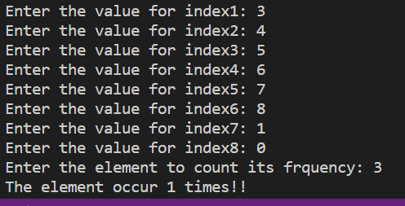

Q22

//Program To Find LCM[Lowest Common Factors] & HCF[HighestC.M] Of To Two Integers

#include<stdio.h>

int main(){

int n,a,b,max,fact=1;

printf("Enter first no.: "); //Taking Two No.

scanf("%d",&a);

printf("Enter second no.: ");

scanf("%d",&b);

printf("Press 1 for LCM or Press 2 for HCF: "); //Taking Operation Type

scanf("%d",&n);

max=(a>b)?a:b;

if(n==1){ //For LCM

while(fact){

if(max%a==0 && max%b==0){

printf("LCM of %d & %d is: %d\n",a,b,max); //Printing LCM

fact=0;

}

max++;

}}

else if(n==2){ //For HCF

for(max;max>=1;max--){

if(a%max==0 && b%max==0){

break;

}}

printf("HCF of %d & %d is: %d",a,b,max); //Printing HCF

}

else{ //For Inputting Value Other Then 1&2

printf("Invalid Operations!!");

}

return 0;

}

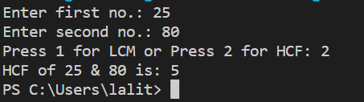

Q23

//PRIME no. or not

#include <stdio.h>

int main(){

int n,i,count=0;

printf("Enter a no. to check whether PRIME no. or not: ");

scanf("%d",&n);

for(i=1;i<=n;i++){

if(n%i==0){

count=count+1;

}

}

if(count==2)

printf("PRIME NO.");

else

printf("NOT PRIME NO.");

}

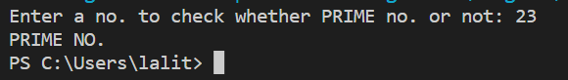

Q24

//KRISHNAMURTI NUM OR ROBINSON NO OR STRONG NO.

#include<stdio.h>

int main(){

int n,temp,rem,fact,sum=0;

printf("Enter a no. for checking whether km or not: ");

scanf("%d",&n);

temp=n;

while(n>0){

rem=n%10;

fact=1;

while(rem>0){

fact=fact*rem;

rem--;

}

sum=sum+fact;

n=n/10;

}

//temp=n;

if(temp==sum)

printf("STRONG NO.");

else

printf("NOT A STRONG NO.");

}

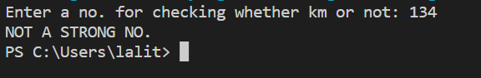

Q25

//FABINACCO SERIES

#include<stdio.h>

int main(){

int n,i,a=0,b=1,c;

printf("Enter the limit to find fabinacco series: ");

scanf("%d",&n);

for(i=1;i<=n;i++){

printf("%d\n",a);

c=a+b;

a=b;

b=c;

}

}

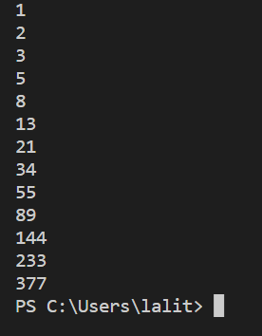

Q26

//ARMSTRONG NUM OR NOT

#include <stdio.h>

int main(){

int n,temp,rem,c,sum=0;

printf("Enter the no. to check whether armstrong or not: ");

scanf("%d",&n);

temp=n;

while(n>0){

rem=n%10;

c=rem*rem*rem;

sum=sum+c;

n=n/10;

}

n=temp;

if(n==sum){

printf("ARMSTRONG");

}

else{

printf("NOT AN ARMSTRONG");

}

}

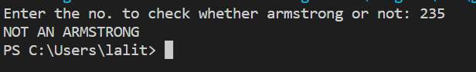

Q27

//PERFECT NO. OR NOT

#include <stdio.h>

int main(){

int n,i,sum=0;

printf("Enter a no. for checking PERFECT NUM OR NOT: ");

scanf("%d",&n);

for(i=1;i<=n/2;i++){

if(n%i==0){

sum=sum+i;

}

}

if(n==sum)

printf("PERFECT NO.");

else

printf("NOT A PERFECT NO.");

}

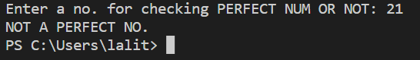

Q28

//POWER OF ANY NO.

#include <stdio.h>

#include<math.h>

int main(){

int a,b,power;

printf("Enter the value: ");

scanf("%d",&a);

printf("Enter the base value: ");

scanf("%d",&b);

power=pow(a,b);

printf("The power of %d is: %d",a,power);

}

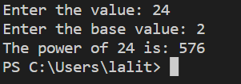

Q29

//ASCII VALUE FINDING

#include <stdio.h>

int main(){

int n;

printf("Enter a no.: ");

scanf("%c",&n);

printf("%d",n);

}

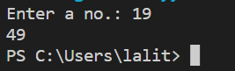

Q30

/*Pascal's Triangle Printing

1

1 1

1 2 1

1 3 3 1

1 4 6 4 1 */

#include<stdio.h>

int main(){

int row,i,j,space,coef=0;

printf("Enter the size of rows: ");

scanf("%d",&row);

for(i=0;i<row;i++){ //For Space Printing

for(space=1;space<=row-i;space++){

printf(" ");}

for(j=0;j<=i;j++){ //For No. Printing

if(j==0 || i==0)

coef=1;

else

coef=coef*(i-j+1)/j;

printf(" %d",coef);

}

printf("\n"); //For New Line

}

return 0;

}

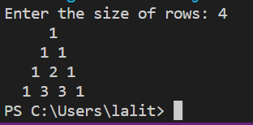

Q31

//SUM OF AN ARRAY ELEMENTS

#include<stdio.h>

int main(){

int n,i,sum=0;

printf("Enter the size of an array: "); //Taking Sixe Of An Array

scanf("%d",&n);

int a[n];

for(i=0;i<n;i++){ //Taking Value Of Elements

printf("Enter the value for index%d: ",i);

scanf("%d",&a[i]);

}

for(i=0;i<n;i++){

sum=sum+a[i];

}

printf("The sum of elements of an array are:%d ",sum);

}

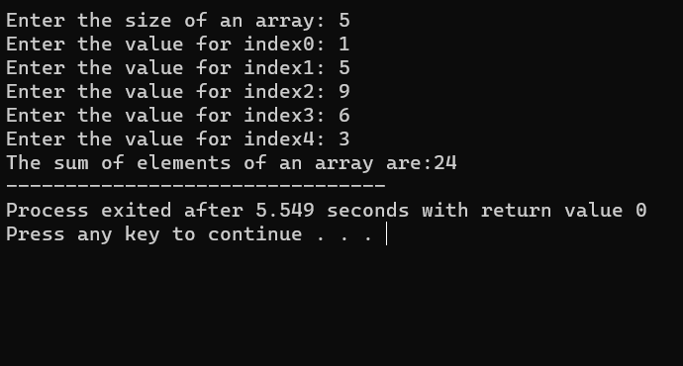

Q32

//Program To Copy One Array Elements To Another Array

#include<stdio.h>

int main(){

int n,j,i,sum=0;

printf("Enter the size of an array: "); //Taking Sixe Of An Array

scanf("%d",&n);

int a[n],b[n];

for(i=0;i<n;i++){ //Taking Value Of Elements

printf("Enter the value for index%d: ",i);

scanf("%d",&a[i]);

}

printf("You Entered:....");

for(i=0;i<n;i++){

printf("%d ",a[i]);

b[i]=a[i];

}

printf("\nArray after copying:....");

for(i=0;i<n;i++){

printf("%d ",b[i]);

}

return 0;

}

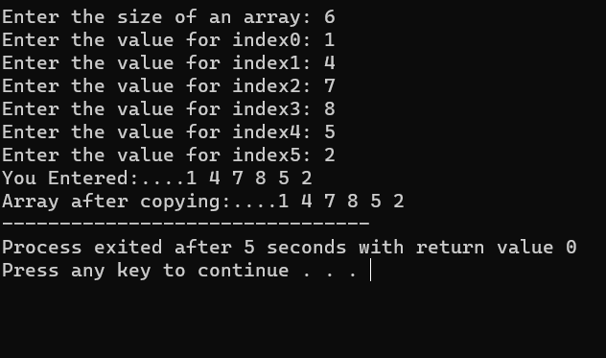

Q33

//INSERTING AN ELEMENT AT ANY GIVEN INDEX

//Program To Insert Any Element At Any Given Point

#include<stdio.h>

int main(){

int n,i,value,pos;

printf("Enter the size of an array: "); //Taking Sixe Of An Array

scanf("%d",&n);

int a[n+1]; //EXTRA BLOCK FOR INSERTION

for(i=0;i<n;i++){ //Taking Value Of Elements

printf("Enter the value for index%d: ",i);

scanf("%d",&a[i]);

}

printf("Enter the INDEX to insert an element: ");

scanf("%d",&pos);

printf("Enter the value of an element: ");

scanf("%d",&value);

for(i=n;i>pos;i--){

a[i]=a[i-1];

}

a[pos]=value;

printf("UPDATED ARRAY!!");

for(i=0;i<=n;i++)

printf("%d",a[i]);

return 0;

}

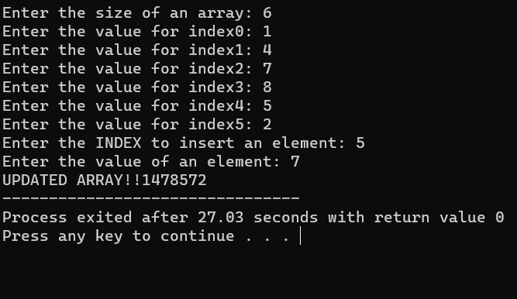

Q34

//Program To Delete An Element In Array At Specified Position

#include<stdio.h>

#define MAX_SIZE 100

int main(){

int arr[MAX_SIZE];

int i, size, pos;

printf("Enter size of the array : "); //Input size and element in array

scanf("%d", &size);

for(i=0; i<size; i++){

printf("Enter the value of index[%d]: ",i);

scanf("%d", &arr[i]);

}

printf("Enter the element position to delete : ");//Input element position to delete

scanf("%d", &pos);

if(pos < 0 || pos > size){ //Invalid delete position

printf("Invalid position! Please enter position between 1 to %d", size);

}

else{ //Copy next element value to current element

for(i=pos-1; i<size-1; i++){

arr[i] = arr[i + 1];

}

size--;

printf("\nElements of array after delete are : ");//Print array after deletion

for(i=0; i<size; i++){

printf("%d ", arr[i]);

}

}

return 0;

}

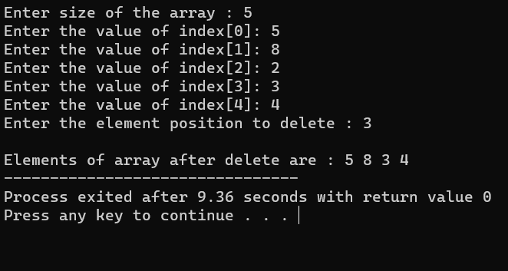

Q35

//Linear Search Programm

#include <stdio.h>

int main(){

int array[100], search, c, n;

printf("Enter the size of an array\n");

scanf("%d",&n);

printf("Enter %d integer(s)\n", n);

for (c=0;c<n;c++) //Taking Value Of Indexes

scanf("%d", &array[c]);

printf("Enter a number to search\n ");

scanf("%d", &search);

for (c = 0; c < n; c++){

if (array[c] == search){ /* If required element is found */

printf("%d is present at location %d.\n", search, c+1);

break;

}

}

if (c == n)

printf("%d isn't present in the array.\n", search);

return 0;

}

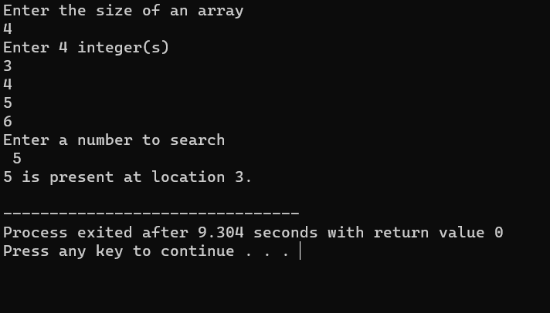

Q36A

//Program To Find Second Largest No.

#include<stdio.h>

int main(){

int i,j,a,n,counter,ave,number[30];

printf ("Enter the limit: ");

scanf ("%d",&n);

for (i=0; i<n; ++i){

printf ("Enter the value of index%d: ");

scanf ("%d",&number[i]);}

for (i=0; i<n; ++i){

for (j=i+1; j<n; ++j){

if (number[i] < number[j]){

a = number[i];

number[i] = number[j];

number[j] = a;

}

}

}

printf ("The numbers arranged in descending order are:\n");

for (i=0; i<n; ++i)

printf ("%10d",number[i]);

printf ("\nThe 2nd largest number is = %d", number[1]);

printf ("\nThe 2nd smallest number is = %d", number[n-2]);

ave = (number[1] +number[n-2])/2;

counter = 0;

for (i=0; i<n; ++i){

if (ave==number[i])

++counter;

}

if (counter==0)

printf("\nThe average of 2nd largest & 2nd smallest is not in the array");

else

printf("\nThe average of 2nd largest & 2nd smallest in array is %d in numbers", counter);

}

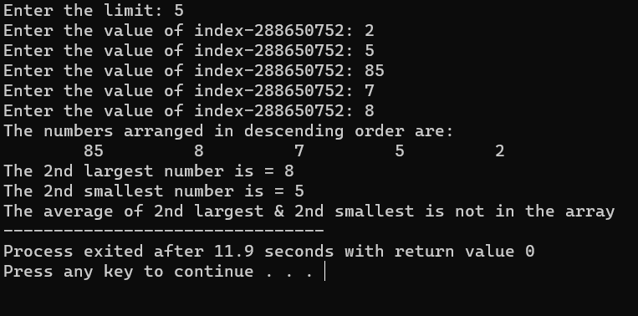

Q36B

//Bubble Sort Program

#include <stdio.h>

int main(){

int arr[50], num, x, y, temp;

printf("Enter the size of an array: ");

scanf("%d",&num);

for(x=0;x<num;x++){ //Taking Value Input

printf("Enter the value of index%d: ",x);

scanf("%d",&arr[x]);

}

x=0;

while(x<num-1){

y=0;

while(y<num-x-1){

if(arr[y]>arr[y+1]){ //Swapping

temp=arr[y];

arr[y]=arr[y + 1];

arr[y+1]=temp;

}

y++;

}

x++;

}

printf("Array after implementing bubble sort: ");

for(x=0;x<num;x++)

printf("%d ",arr[x]);

return 0;

}

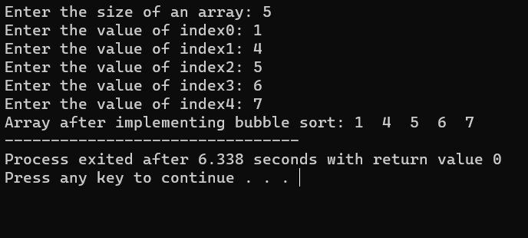

Q37

//Program To Remove Duplicate Element In An Array

#include <stdio.h>

#define MAX_SIZE 100 // Maximum array size

int main()

{

int arr[MAX_SIZE];

int i, j, size, count = 0;

printf("Enter size of the array : "); //Taking Size Of AN Array

scanf("%d",&size);

for(i=0;i<size;i++){ //Taking Value Of Element IN An Array

printf("Enter the value of index%d: ",i);

scanf("%d",&arr[i]);

}

for(i=0; i<size; i++){

for(j=i+1; j<size; j++){ //Checkm For Duplicate Element

if(arr[i] == arr[j]){

count++;

break;

}

}

}

printf("\nTotal number of duplicate elements found in array = %d", count);

return 0;

}

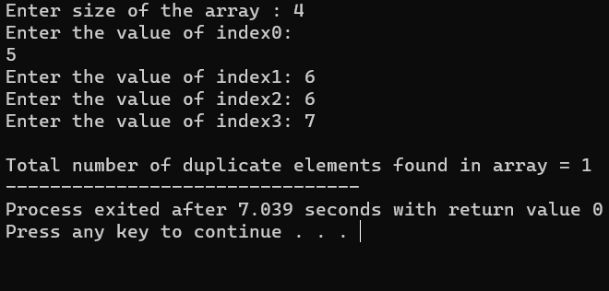

Q38

//Scalar Matrix Multiplication

#include <stdio.h>

#define SIZE 3 // Maximum size of the array

int main(){

int num,n,i,j;

printf("Enter the size of array: ");

scanf("%d",&n);

int A[n][n];

for(i=0;i<n;i++){

for(j=0;j<n;j++){

printf("Enter the value of index%dx%d: ",i,j);

scanf("%d",&A[i][j]);

}}

printf("Enter any number to multiply with matrix A: ");

scanf("%d",&num);

for(i=0;i<n;i++){

for(j=0;j<n;j++){

A[i][j]=num*A[i][j];

}}

printf("\nResultant matrix c.A = \n");

for(i=0;i<n;i++){

for(j=0;j<n;j++){

printf("%d ",A[i][j]);

}

printf("\n");

}

return 0;

}

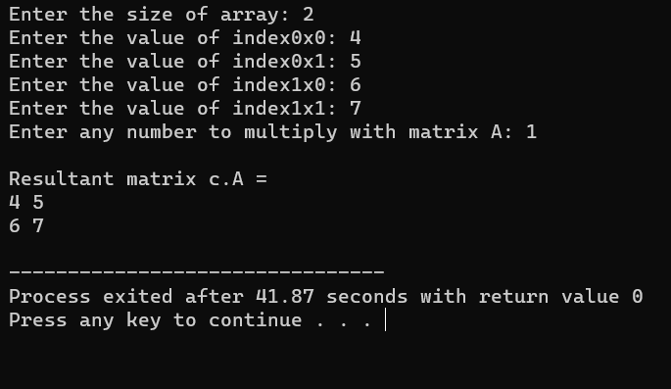

Q40

//Find Out Transpose Of A Matrix

#include<stdio.h>

int main(){

int n,m,i,j;

printf("Enter the size of rows: "); //Taking Size Of Rows & Column

scanf("%d",&n);

printf("Enter the size of column: ");

scanf("%d",&m);

int a[n][m];

for(i=0;i<n;i++){ //Inputing Values Of Elements

for(j=0;j<m;j++){

printf("Enter the value of index%d%d: ",i,j);

scanf("%d",&a[i][j]);

}

}

for(i=0;i<n;i++){

for(j=0;j<m;j++){

printf("%d ",a[i][j]);

}

printf("\n");

}

printf("Array Transpose Are!!\n");

for(i=0;i<m;i++){

for(j=0;j<n;j++){

printf("%d ",a[j][i]);

}

printf("\n");

}

}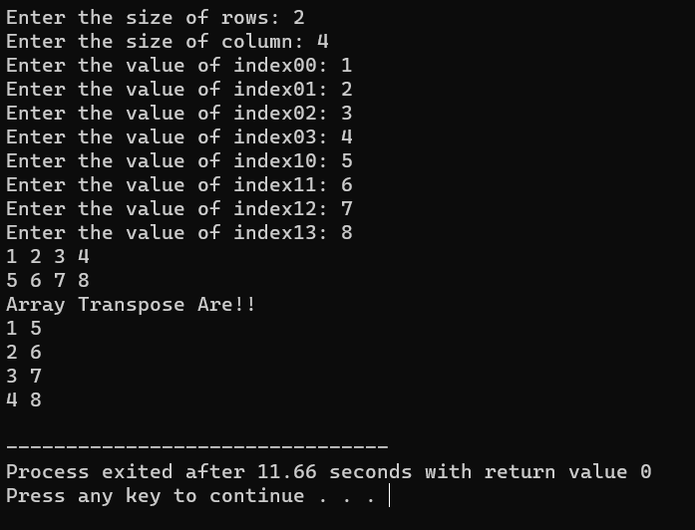

Q41

//Check Whether A Matrix Is Identity Matrix Or Not

#include<stdio.h>

int main(){

int a[2][2],i,j,flag=0;

for(i=0;i<2;i++){ //Taking Values Of Matrix

for(j=0;j<2;j++){

printf("Enter the value of inedx%d%d of Matrix1: ",i,j);

scanf("%d",&a[i][j]);

}}

for(i=0;i<2;i++){ //Checking Identity Matrix Or Not

for(j=0;j<2;j++){

if(i==j && a[i][j]==1){

flag=1;

}

else if(i!=j && a[i][j]!=1)

flag=0;

}}

if(flag==1){

printf("IDENTITY MATRIX!!");

}

else{

printf("NOT A IDENTITY MATRIX!!");

}

}

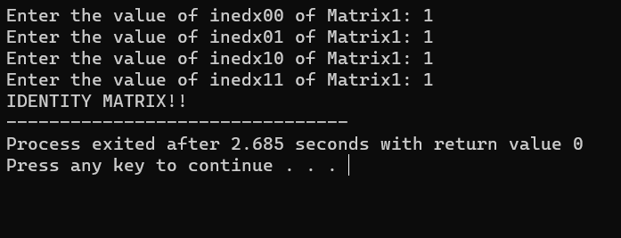

Q42

//Merging Of Two Arrays

#include<stdio.h>

#include<conio.h>

int main(){

int arr1[50], arr2[50], size1, size2, i, k, merge[100];

printf("Enter Array 1 Size: ");

scanf("%d", &size1);

printf("Enter Array 1 Elements: ");

for(i=0; i<size1; i++){

scanf("%d", &arr1[i]);

merge[i] = arr1[i];

}

k = i;

printf("\nEnter Array 2 Size: ");

scanf("%d", &size2);

printf("Enter Array 2 Elements: ");

for(i=0; i<size2; i++){

scanf("%d", &arr2[i]);

merge[k] = arr2[i];

k++;

}

printf("\nThe new array after merging is:\n");

for(i=0; i<k; i++)

printf("%d ", merge[i]);

return 0;

}

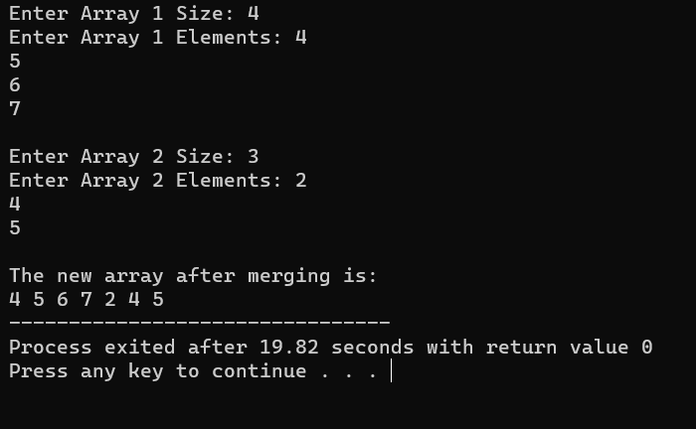

Q43

//All String Operations

# include <stdio.h>

# include <string.h>

int main(){

char str1[40], str2[40] ;

printf("Enter the first string : ") ;

gets(str1) ;

printf("Enter the second string : ") ;

gets(str2) ;

printf("\nString 1 = %s & String 2 = %s ", str1, str2) ;

printf("\nUppercase is : %s and %s", strupr(str1), strupr(str2));

printf("\nLowercase is : %s and %s", strlwr(str1), strlwr(str2));

printf("\nReverse is : %s and %s", strrev(str1), strrev(str2)) ;

printf("\nString copy is : %s ", strcpy(str1,str2));

printf("\nConcatenation is : %s ", strcat(str1,str2));

return 0;

}

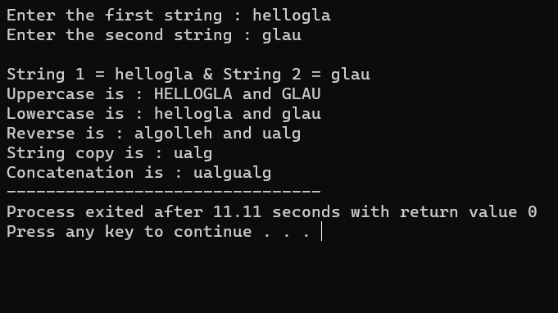

Q44

//Checking A String Is Palindrom Or Not.....Without Using String Functions

#include<stdio.h>

#include<string.h>

int main(){

char str[100];

int i,flag=0,len;

printf("Enter the string to check palindrome or not: ");

gets(str);

len=strlen(str);

for(i=0;i<len;i++){

if(str[i]!=str[len-i-1]){

flag=1;

break;

}

}

if(flag==0)

printf("PALINDROME!!");

else

printf("NOT A PALINDROME!!");

}

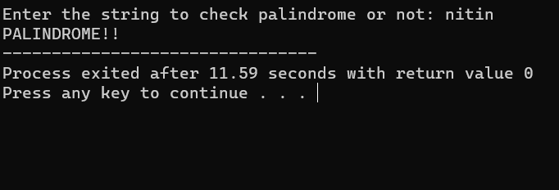

Q45

//Count Frequency Of A Given String

#include<stdio.h>

int main(){

char str[20],a;

int c=0,i;

printf("Enter a string: ");

gets(str);

printf("Enter a character to count its frequency: ");

scanf("%c",&a);

for(i=0;str[i]!='\0';i++){

if(a==str[i]){

c++;

}

}

printf("%c occur %d times.",a,c);

return 0;

}

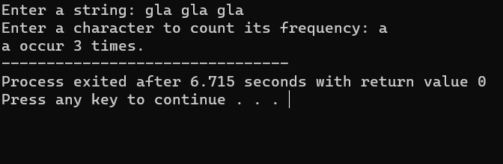

Q46

//Program To Find Diameter,Area&Circumference Of A Circle Given Radius

#include <stdio.h>

#include <math.h> // Used for constant PI referred as M_PI

double getDiameter(double radius); //Function declaration

double getCircumference(double radius);

double getArea(double radius);

int main() {

float radius, dia, circ, area;

printf("Enter radius of circle: "); //Taking Radius Of A Circle

scanf("%f", &radius);

dia = getDiameter(radius); // Call getDiameter function

circ = getCircumference(radius); // Call getCircumference function

area = getArea(radius); // Call getArea function

printf("Diameter of the circle = %.2f units\n", dia);

printf("Circumference of the circle = %.2f units\n", circ);

printf("Area of the circle = %.2f sq. units", area);

}

double getDiameter(double radius){

return (2 * radius);

}

double getCircumference(double radius) {

return (2 * M_PI * radius);

}

double getArea(double radius){

return (M_PI * radius * radius);

}

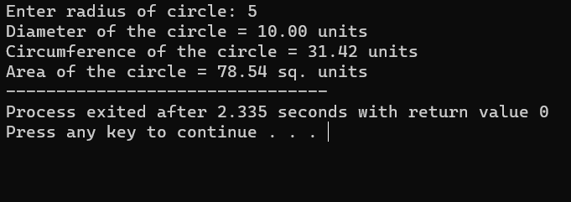

Q47

//Program To Check A No. Is Armstrong, Perfect, And Prime Or nOT

#include <stdio.h>

#include <math.h>

int isPrime(int num); //Function declarations

int isArmstrong(int num);

int isPerfect(int num);

int main(){

int num;

printf("Enter any number: ");

scanf("%d", &num);

if(isPrime(num)){ // Call isPrime() functions

printf("%d is Prime number.\n", num);

}

else{

printf("%d is not Prime number.\n", num);

}

if(isArmstrong(num)){ // Call isArmstrong() function

printf("%d is Armstrong number.\n", num);

}

else{

printf("%d is not Armstrong number.\n", num);

}

if(isPerfect(num)){ // Call isPerfect() function

printf("%d is Perfect number.\n", num);

}

else{

printf("%d is not Perfect number.\n", num);

}

return 0;

}

int isPrime(int num){//* Check whether a number is prime or not.

int i; //* Returns 1 if the number is prime otherwise 0.

for(i=2; i<=num/2; i++){

if(num%i == 0){

return 0;}}

return 1;

}

int isArmstrong(int num){ //Check whether a number is Armstrong number or not.

int lastDigit, sum, originalNum, digits;//Returns 1 if the number is Armstrong number otherwise 0.

sum = 0;

originalNum = num;

digits = (int) log10(num) + 1; //Find total digits in num

while(num > 0){ //Calculate sum of power of digits

lastDigit = num % 10; // Extract the last digit

sum = sum + round(pow(lastDigit, digits));// Compute sum of power of last digit

num = num / 10; // Remove the last digit

}

return (originalNum == sum);

}

int isPerfect(int num){ //Check whether the number is perfect number or not.

int i, sum, n; //Returns 1 if the number is perfect otherwise 0.

sum = 0;

n = num;

for(i=1; i<n; i++){ // If i is a divisor of num

if(n%i == 0){

sum += i;

}}

return (num == sum);

}

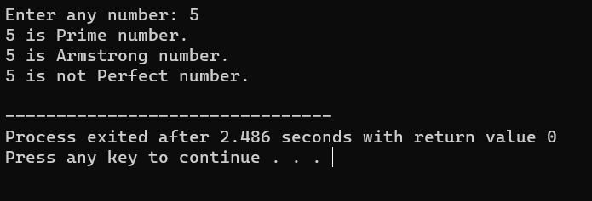

Q48

//Add Two No. Using Pointers

#include<stdio.h>

int main(){

int *p,*q,a,b,r;

printf("Enter the num1: ");

scanf("%d",&a);

printf("Enter the num2: ");

scanf("%d",&b);

p=&a; //Giving address of variables to pointers

q=&b;

r=*p+*q;

printf("The sum of no.: %d",r);

// printf("The sum of no. %d & %d is: %d.",a,b,*r);

return 0;

}

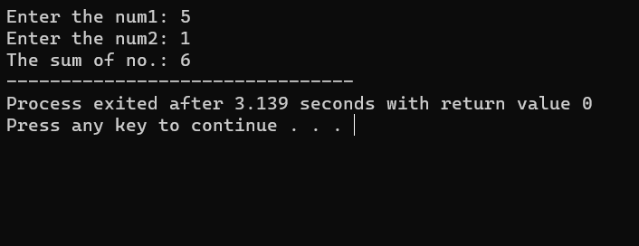

Q49

//Call by Value Example - Swapping 2 numbers using Call by Value

#include <stdio.h>

void swap(int, int);

int main(){

int x, y;

printf("Enter the value of x and y\n");

scanf("%d%d",&x,&y);

printf("Before Swapping\nx = %d\ny = %d\n", x, y);

swap(x, y);

printf("After Swapping\nx = %d\ny = %d\n", x, y);

return 0;

}

void swap(int a, int b){

int temp;

temp = b;

b = a;

a = temp;

printf("Values of a and b is %d %d\n",a,b);

}

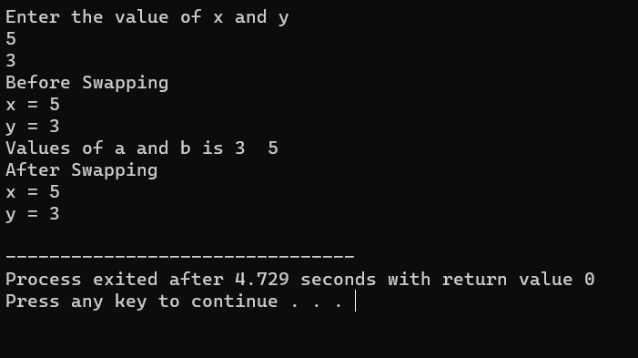

Q50 //Copy Array Using Pointers

#include <stdio.h>

#define MAX_SIZE 100 // Maximum array size

void printArray(int arr[], int size);//Function declaration to print array *

int main(){

int source_arr[MAX_SIZE], dest_arr[MAX_SIZE];

int size, i;

int *source_ptr = source_arr; // Pointer to source_arr

int *dest_ptr = dest_arr; // Pointer to dest_arr

int *end_ptr;

printf("Enter size of array: ");//Input size and elements in source array

scanf("%d", &size);

printf("Enter elements in array: ");

for (i = 0; i < size; i++){

scanf("%d", (source_ptr + i));

}

end_ptr = &source_arr[size - 1];// Pointer to last element of source_arr

printf("\nSource array before copying: ");//Print source and destination array before copying

printArray(source_arr, size);

printf("\nDestination array before copying: ");

printArray(dest_arr, size);

while(source_ptr <= end_ptr){//Run loop till source_ptr exists in source_arr

*dest_ptr = *source_ptr;// memory range.

source_ptr++; //Increment source_ptr and dest_ptr

dest_ptr++;

}

printf("\n\nSource array after copying: ");// Print source and destination array after copying

printArray(source_arr, size);

printf("\nDestination array after copying: ");

printArray(dest_arr, size);

return 0;

}

void printArray(int *arr, int size){//Function to print array elements.

int i; //@arr Integer array to print.

for (i = 0; i < size; i++){ //@size Size of array.

printf("%d, ", *(arr + i));

}

}

